EIA Analysis Fretherne with Saul Parish Council Response to the Request for Screening Opinion

Date: 14th January 2025

Request for Screening Opinion under Regulation 6 of the Town and Country Planning (Environmental Impact Assessment) Regulations 2017
Proposed Solar Farm and Battery Storage facility (49.5 MW)
At: Land at Epney, GL2 7LL

Introduction

Fretherne with Saul Parish Council (FwSPC) notes the request, by Pathfinder Clean Energy (PACE), for an Environmental Impact Assessment (EIA) Screening Opinion in their letter of 5th December 2024.

Described in its simplest way, this project is one that will potentially transform approximately 50 hectares of productive agricultural land into an industrial site. This will have an effect on the environment.

The fact that the site is to be used for the industrial production of electricity using solar power is irrelevant - HMG guidance states: “this does not mean that the need for renewable energy automatically overrides environmental protections and the planning concerns of local communities.” and “… it is important that the planning concerns of local communities are properly heard in matters that directly affect them.”

Additionally, HMG guidance for the planning for renewable energy states “There are no hard and fast rules about how suitable areas for renewable energy should be identified, but in considering locations, local planning authorities will need to ensure they take into account the requirements of the technology (see paragraphs 12-13) and, critically, the potential impacts on the local environment, including from cumulative impacts (see paragraphs 43-44). The views of local communities likely to be affected should be listened to.”

The document provided to FwSPC by Stroud District Council, clearly shows that the proposed development meets the criteria in column 2 of Schedule 2 – specifically, the proposed development is larger than 0.5 ha.

Taking into consideration the mandated actions given in Schedule 3:
“1. The characteristics of development must be considered with particular regard to—
(a) the size and design of the whole development
(b) cumulation with other existing development and/or approved development
…
(f) the risk of major accidents and/or disasters relevant to the development concerned, including those caused by climate change, in accordance with scientific knowledge
(g) the risks to human health (for example, due to water contamination or air pollution).”

FwSPC see the following as key pertinent facts about the proposed development:
- This development is the largest size that can be assessed by an LPA (Local Planning Authority)
- There is an industrial site of the same type being built 500m from the boundary of the proposed site – Moreton Valence Solar Farm (the size of the proposed site is a single plot of land 600m x 840m)
- The proximity of these two sites means all assessments must be done cumulatively to include both sites.
- The proposed design includes installing 66 large containers of batteries (each 12m x 2.4m x 2.9m - approximately the size of a standard shipping container) - type not defined, but industry standard for this type of industrial installation is to use Li-Ion batteries.
- In the event of a battery fault the proposed development is designed to dump over 200 tons (200 m3) of toxic wastewater into the environment, including local water courses and the River Severn.

These are described in more detail below in the HMG Environmental Impact Assessment Screening Checklist. (Note: for brevity sections with no comments have not been included. However, FwSPC reserves the right to add to these sections in the future, if information not currently in their possession becomes available.)

Process Overview

The process followed to prepare this document is the HMG process to assess the need for an EIA. The diagram below highlights the steps followed in this process.

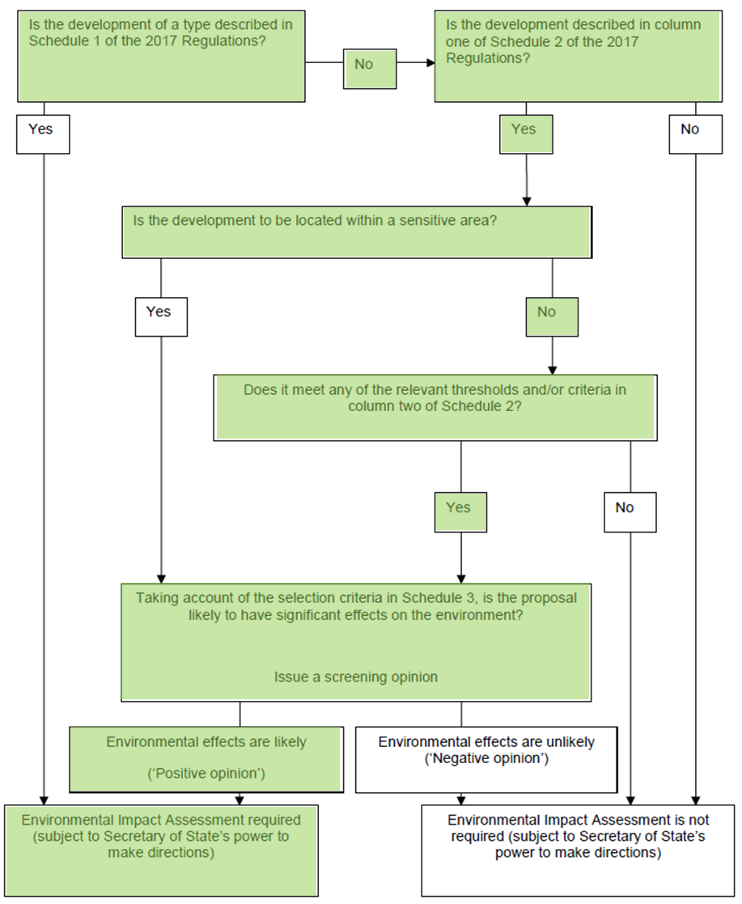

This page is intentionally blank

Detailed Assessment

Whilst the Parish Council acknowledges that they have been advised by the Planning Officer that no response is required, taking into consideration the published HMG guidance on the process to be followed, the HMG Environmental Impact Assessment Screening Checklist (EIASC)to be used, and the UK Statutory Instruments applying to this, FwSPC assess that the following environmental effects are relevant to the proposed development.

A Screening Criteria Question | B Response to the Screening Criteria  Question in Column A (Yes/No and explanation of reasons) | C Is a Significant Effect Likely?  (Yes/No and explanation of reasons (NB: if the answer in Column B is ‘No’, Column C is not applicable))
5.3 Are there any areas on/around the location which contain important, high quality or scarce resources which could be affected by the project, e.g. forestry, agriculture, water/coastal, fisheries, minerals? | YES:  The River Severn  The River Frome | The Proposed industrial site is close to both the River Severn (380m) and is next to the River Frome - a tributary of the River Severn. A watercourse flows through the middle of the proposed site. In the event of a battery fault in the BESS, the proposed development is designed to dump 200 tons of toxic wastewater into the local water table - via the on-site soak-aways. It should also be expected that this toxic waste would enter the water course flowing through the site and into the rivers next to the site. The amount of toxic run-off from the site would be increased by any actions to mitigate the BESS fire, e.g. actions by the Emergency Services to control the fire. (NB The industry-standard battery type used in a BESS is a Li-Ion type battery and Li-Ion fires cannot be extinguished.)
6.1 Will the project produce solid wastes during construction or operation or decommissioning? | YES:  Solar Pannels  BESS Batteries  BESS units  Substation  Hard Standings  Soakaways | The current methods available to re-cycle solar panels are difficult and require large amounts of energy.  The BESS batteries will require specialist recycling.  The Substation, hard standings and soakaways will all need specialist processes for their safe and effective removal.  All of the waste from the use of the site for the industrial production of electricity will need to be removed from the site during the decommissioning process.

A Screening Criteria Question | B Response to the Screening Criteria  Question in Column A (Yes/No and explanation of reasons) | C Is a Significant Effect Likely?  (Yes/No and explanation of reasons (NB: if the answer in Column B is ‘No’, Column C is not applicable))
7.1 Will the project release pollutants or any hazardous, toxic or noxious substances to air? | YES:  Toxic fumes into the air  (NB: Potential cumulative effect with the existing solar farm next to the proposed site location) | In the event of a battery fault in the BESS there would be a release of toxic fumes from the batteries contained in the BESS. Due to the number and size of the BESS units on the proposed site, as well as the locations of the units within the site, it should be expected that the amount of airborne toxic pollutants released would be significant. (NB The industry-standard battery type used in a BESS is a Li-Ion type battery and Li-Ion fires cannot be extinguished.)
7.2 Will the project cause noise and vibration or release of light, heat, energy or electromagnetic radiation? | YES:  Noise (potentially to a level that causes permanent hearing loss.)  (NB: Cumulative effect with the existing solar farm next to the proposed site location) | The individual BESS units will each cause significant noise to a significant level. Noise levels from BESS units have been measured at levels that cause permanent hearing loss. Due to the number of BESS units proposed to be installed on the site, the noise from the site during normal use should be considered to be significant.
7.3 Will the project lead to risks of contamination of land or water from releases of pollutants onto the ground or into surface waters, groundwater, coastal waters or the sea? | YES:  Toxic run-off into the following:  Groundwater  River Severn  River Frome  Severn Estuary  ((NB: Potential cumulative effects with the existing solar farm next to the proposed site location - groundwater) | In the event of a battery fault in the BESS, the proposed development is designed to dump 200 tons of toxic wastewater into the local water table (groundwater) - via the on-site soak-aways. It should also be expected that this toxic waste would also enter the water course flowing through the site and into the rivers next to the site (Rivers Severn and Frome). The amount of toxic run-off from the site would be increased by any actions to mitigate the BESS fire, e.g. actions by the Emergency Services to control the fire.  (NB The industry-standard battery type used in a BESS is a Li-Ion type battery and Li-Ion fires cannot be extinguished.)

A Screening Criteria Question | B Response to the Screening Criteria  Question in Column A (Yes/No and explanation of reasons) | C Is a Significant Effect Likely?  (Yes/No and explanation of reasons (NB: if the answer in Column B is ‘No’, Column C is not applicable))
8.1 Will there be any risk of major accidents (including those caused by climate change, in accordance with scientific knowledge) during construction, operation or decommissioning? | YES:  BESS fire  BESS explosion  Severe environmental contamination  Flooding from the sea (sea surge area)  Flooding from increased rainfall  (NB: Potential cumulative effects with the existing solar farm next to the proposed site location (all except flooding from the sea) | There is a risk of a fire starting in the BESS in the proposed industrial site, this is shown by the industrial site containing a 200 ton water storage tank solely to deal with a BESS fire. This risk of a BESS fire or BESS explosion will increase as temperatures rise due to climate change. In the event of an individual battery catching fire, there is a risk of the fire spreading due to thermal runaway. This would then increase the risk of an explosion in the affected BESS unit. It should be expected that shrapnel damage from this explosion would then cause damage to, and fires in, neighbouring BESS units.  Equally, due to climate change the risk of flooding in the local area and on this site, acknowledged as a Level 3 flood risk (sea surge), is significantly increased. There has already been widespread historic flooding on the proposed site.

A Screening Criteria Question | B Response to the Screening Criteria  Question in Column A (Yes/No and explanation of reasons) | C Is a Significant Effect Likely?  (Yes/No and explanation of reasons (NB: if the answer in Column B is ‘No’, Column C is not applicable))
8.2 Will the project present a risk to the population (having regard to population density) and their human health during construction, operation or decommissioning? (for example, due to water contamination or air pollution) | YES:  Water contamination  Air pollution  Noise pollution  Mental health  (NB: Cumulative effects with the existing solar farm next to the proposed site location) | The proposed Industrial site is close to sites of human occupation - the villages of Saul and Upper Framilode, and local farms. As stated in §8.1, there is a not an insignificant risk of a fire in the BESS. A fire in the BESS, will present the following risks to the local and wider population:  - 200 tons, or more, of toxic wastewater being released into the water table and into the rivers and watercourses flowing through, and next to the site. The proposed industrial site is up-stream of the human habitation detailed above.  - Large quantities of toxic fumes being released into the atmosphere. As well as the population centres detailed above, the site is also close to the villages of Frampton on Severn, Whitminster, Epney and Longney and the M5. Expert advice would need to be sought on the effects of a BESS fire and the subsequent toxic fumes released on the populations of Arlingham and Gloucester as well as local infrastructure such as the canal and M5.  (NB The industry-standard battery type used in a BESS is a Li-Ion type battery and Li-Ion fires cannot be extinguished.)  - During the construction phase the constant 12 hours a day for five days a week, and 8 hours a day for one day of the week, noise is likely to impact the mental and cognitive health of the local population.  As notes above, noise produced by an industrial BESS installation, such as the proposed one, produces noise pollution that can permanently cause hearing loss.  The impact of the noise produced by the construction phase will have a significant effect on the local population, including on their mental health. The effects of similar construction work were felt during recent work to maintain the flood defences on the River Frome.

A Screening Criteria Question | B Response to the Screening Criteria  Question in Column A (Yes/No and explanation of reasons) | C Is a Significant Effect Likely?  (Yes/No and explanation of reasons (NB: if the answer in Column B is ‘No’, Column C is not applicable))
9.1 Are there any water resources including surface waters, e.g. rivers, lakes/ponds, coastal or underground waters on or around the location which could be affected by the project, particularly in terms of their volume and flood risk? | YES:  Volume and flood risk of:  Pond – wildlife pond on site  Canal – Gloucester Sharpness  Rivers – Severn, Frome  Drainage ditches and rhynes | There are numerous water courses running through and adjacent to the proposed industrial site including a pond, canal, major tidal river and drainage rhynes.  It has also come to FwSPC attention that the Environment Agency are planning to amend their Shoreline Management Plan and their coverage of the flood defences along the River Severn. It is believed that this will have an effect on the current flood defences.

A Screening Criteria Question | B Response to the Screening Criteria  Question in Column A (Yes/No and explanation of reasons) | C Is a Significant Effect Likely?  (Yes/No and explanation of reasons (NB: if the answer in Column B is ‘No’, Column C is not applicable))
10.1 Are there any protected areas which are designated or classified for their terrestrial, avian and marine ecological value, or any non-designated  / non-classified areas which are important or sensitive for reasons of their terrestrial, avian and marine ecological value, located on or around the location and which could be affected by the project? (e.g. wetlands, watercourses or other waterbodies, the coastal zone, mountains, forests or woodlands, undesignated nature reserves or parks. (Where designated indicate level of designation  (international, national, regional or local))). | YES:  River Severn Basin Management Plan - National  Severn Estuary SPA- International  Severn Estuary SAC- International  Severn Estuary Ramsar- International  Wye Valley and Forest of Dean bat SAC- International  Walmar Common SPA - International  Walmar Common Ramsar- International  Woodchester Mansion SSSI- International  Littledean Hall SSSI – Greater and Lesser Horseshoe bats- International  WWT Slimbridge | The proposed industrial site is within the area covered by the river basin management plan for the Severn River Basin District and is close to the River Severn (380m) upstream of the Severn Estuary SPA, SAC, and Ramsar site.  A BESS fire at this site would affect all of these down-stream areas.  Greater horseshoe bats have a monitored roost site at Woodchester Mansion  The construction phase and existence of the solar farm and BESS will affect the functionally linked roosts  The site lies within the Lesser Horseshoe bat 3km maternity buffer for an identified breeding site.

A Screening Criteria Question | B Response to the Screening Criteria  Question in Column A (Yes/No and explanation of reasons) | C Is a Significant Effect Likely?  (Yes/No and explanation of reasons (NB: if the answer in Column B is ‘No’, Column C is not applicable))
10.2 Could any protected, important or sensitive species of flora or fauna which use areas on or around the site, e.g. for breeding, nesting, foraging, resting, over-wintering, or migration, be affected by the project? | YES  Fauna (see Column C for details)  (NB: Cumulative effects with the existing solar farm next to the proposed site location) | Converting the proposed site to industrial use has the following potential effects on the local fauna:  - The proposed industrial site is on farmland and other rural land that has been identified as being able to support the following protected species:  - Bats  - Breeding and wintering birds  - Dormice  - Amphibians  - Snipe  - Curlew  - Kingfisher  - Reptiles  - Otters  - Badgers  - Water voles  - The proposed site is close to the Severn Estuary (2km), consideration should be given to nationally and internationally important populations of seabirds, waterfowl, waders, and other bird species that breed, over-winter, and migrate through this area.  The proposed site is between two significant populations of rare bat species (Lesser and Greater Horseshoe bats).

A Screening Criteria Question | B Response to the Screening Criteria  Question in Column A (Yes/No and explanation of reasons) | C Is a Significant Effect Likely?  (Yes/No and explanation of reasons (NB: if the answer in Column B is ‘No’, Column C is not applicable))
11.2 Is the project in a location  where it is likely to be highly visible to many people? (If so, from where, what direction, and what distance?) | YES  From numerous locations, all from less than 10m distance. | The towpath of the Gloucester and Sharpness Canal runs alongside the boundary of the site. The proposed location of the substation is adjacent to the towpath. Due to the height (9m) and size of the substation, there is a strong possibility that it will be visible to people walking along the towpath and people using the canal. NB this part of the Gloucester to Sharpness Canal has a higher-than-normal occurrence of both people walking along the canal towpath and using the canal due to its proximity to Saul Junction, and the marina located there. This stretch of waterway also has a higher-than-average domicile usage.
12.1 Are there any areas or features which are protected for their cultural heritage or archaeological value, or any non-designated / classified areas and/or features of cultural heritage or archaeological importance on or around the location which could be affected by the project (including potential impacts on setting, and views to, from and within)? Where designated indicate level of designation (international, national, regional or local). | YES  Roman archaeology  Post-mediaeval archaeology  Listed Buildings Grade I, II and II*on the National Heritage List -  The Framilodes: Framilode Mill - Grade II 830m  Lea Court Farm - Grade II 200m  Baldwin House and Cottage - Grade II 200m  Saul: St James - Grade II* 940m  Malthouse Farmhouse - Grade II 1200m  Lion House - Grade II 1100m  Whitminster: St Andrew’s Church - Grade II 500m  Whitminster Manor House - Grade II 620m  Packthorne Farmhouse – Grade II 430m  Moreton Valence: Milepost at National Grid Ref SO 767 102 - Grade II on the towpath and close to the site  Wider: IHCA – National  Saul Conservation Area – National | The proposed site is on land that has been subjected to recent geophysical survey and has been identified as possibly containing archaeological remains. These remains potentially contain significant Roman remains and post-Mediaeval agricultural activity. There a significant number of listed buildings, including churches, IHCA – there will be impact to their visual sight lines and historic integrity.

A Screening Criteria Question | B Response to the Screening Criteria  Question in Column A (Yes/No and explanation of reasons) | C Is a Significant Effect Likely?  (Yes/No and explanation of reasons (NB: if the answer in Column B is ‘No’, Column C is not applicable))
13.1 Are there any routes on or around the location which are used by the public for access to recreation or other facilities, which could be affected by the project? | YES  Numerous Public Rights of Way  The Gloucester and Sharpness Canal  Severn Way | If the proposed site was changed from a rural land scape to industrial use, a number of routes used by the public for recreation would be affected:  - The proposed site has a number of Public Rights of Way that cross it. All of these would be adversely affected if the land was changed from rural countryside to industrial use.  - The entire SE boundary of the site is the towpath of the Gloucester and Sharpness Canal. Views from this towpath would be severely affected if this site was turned to industrial use - the screening of the industrial site proposed to hide the site from view would effectively remove all of the views over the Severn Vally from this towpath. NB this part of the Gloucester and Sharpness Canal has a higher-than-normal occurrence of both people walking along the canal towpath and using the canal due to its proximity to Saul Junction, the marina located there, and domicile usage.  - People using the PROW that cross the site would be subjected to noise level that are defined as causing permanent damage to hearing.  - If the proposed change of the land to industrial use were to go ahead, there would also be an impact on local businesses that support people using the routes described above.
13.2 Are there any transport routes on or around the location which are susceptible to congestion, or which cause environmental problems, which could be affected by the project? | YES  The main transport route would effectively close the proposed road, which is designated as a GCC L3 route.  The proposed transport route has not been shown to be safe for use by the intended traffic. | The route proposed to bring vehicles to-and from the proposed site is along an unclassified road (GCC L-3). This lane would only be able to have large HGV, or similar, vehicles travelling along it in one direction at any time.  There is also no evidence that the route is suitable, or safe, for the type and quantity of road traffic that would be required to build an industrial site of this type.  The proposed route would severely affect vehicular access to the local area - it is the main access route to the area from Gloucester and from Junction 12 on the M5 (GCC L3 designation).  The route also involves a canal bridge with a weight restriction of 25T MGW.

A Screening Criteria Question | B Response to the Screening Criteria  Question in Column A (Yes/No and explanation of reasons) | C Is a Significant Effect Likely?  (Yes/No and explanation of reasons (NB: if the answer in Column B is ‘No’, Column C is not applicable))
14.1 Are there existing land uses or community facilities on or around the location which could be affected by the project? E.g. housing, densely populated areas, industry / commerce, farm/agricultural holdings, forestry, tourism, mining, quarrying, facilities relating to health, education, places of worship, leisure /sports / recreation. | YES  Numerous local facilities (see Column C for details)  (NB: Cumulative effects with the existing solar farm next to the proposed site location) | If the site was converted to industrial use, as proposed, there would be the following effects:  - The people living in the surrounding villages of Saul and Upper Framilode would be permanently subjected to the noise pollution created by the site. The effects of this noise pollution would be increased during the night when any other noise in the area would not be present.  - Local tourism would be affected for the reasons stated in §11.2, 13.1, and 13.2.  - The proposed access route and site construction would severely affect the Anchor Inn adjacent to the proposed site access point.  - Site construction would severely affect the Ship Inn at Upper Framilode and the Stables Cafe at Saul Junction.  - St James Saul,  - St Peters Framilode  - Wheatenhurst Church  - Residential and recreational use of Gloucester and Sharpness Canal and affiliated marina  - Baldwins Farm  - Baldwins Brook Glamping  - Saul Community Hall  - Wycliffe College Rowing Club  - Shipton Mill  - Severn Way in Framilode and towards Epney  - Culverhay Surgery, Whitminster Lane  - Numerous B&Bs and Airbnb’s

A Screening Criteria Question | B Response to the Screening Criteria  Question in Column A (Yes/No and explanation of reasons) | C Is a Significant Effect Likely?  (Yes/No and explanation of reasons (NB: if the answer in Column B is ‘No’, Column C is not applicable))
16.1 Could this project together with existing and/or approved development result in cumulation of impacts together during the construction/operation phase? | YES  There is already a large solar farm being built next to the proposed site and another solar farm under construction in Longney  Plan to build c3000 houses at Whitminster  Planned new business park and football stadium | There is a large solar farm (49.9 MW) being built next to the proposed site (500m from the site boundary – the proposed site is 600m x 800m). The existing noise effects, and any potential effects on local tourism and the local population from the existing Solar Farm, would be compounded by this proposal to create a second industrial site next to the existing one.  There is a solar farm in Longney that has started, and apparently paused, construction. All environmental effects of the two developments should be considered cumulatively, particularly in relation to transport routes.  Proposed c3000 houses on flood plains/meadows at Whitminster, Standish etc likely to increase water levels in the Frome and increase flood risk.  Planned new football stadium at Junction 13 (contiguous with planned housing development)
17.1 Is the project likely to lead to transboundary effects? | YES  Environmental effects would affect land and water in both England and Wales. | As the Severn Estuary has banks in both England and Wales and the River basin management plan for the Severn River Basin District covers land in both England and Wales; the proposed industrial site has environmental effects that are transboundary.

The Town and Country Planning (Environmental Impact Assessment) Regulations 2017 Screening Matrix was used as a basis for the assessment if an EIA is required for the proposed development.

This page is intentionally blank

Conclusion

In conclusion: After following the HMG process to assess if an EIA is needed, shown above, and taking into consideration the instructions contained in the statutory instrument; the wide range and severity of environmental effects from the proposed development leads Fretherne with Saul Parish Council to conclude that an EIA must be carried out in respect to the proposal by Pathfinder Clean Energy (PACE) to build a Solar Farm and BESS (Battery Energy Storage System) on land between Epney and Upper Framilode.

Department for Communities and Local Government, Planning practice guidance for renewable and low carbon energy (2013), para 5
Ibid, para 8
2024/0619/EIAS, EIA Screening Cover Letter [sic], page 1
The Town and Country Planning (Environmental Impact Assessment) Regulations 2017, Schedule 3
Stroud District Renewable Energy Resources Assessment, p52
Environmental Impact Assessment, Paragraph: 018 Reference ID: 4-018-20170728 (URL: https://www.gov.uk/guidance/environmental-impact-assessment - downloaded 03Jan2025)
Environmental Impact Assessment, Paragraph: 018 Reference ID: 4-018-20170728 (URL: https://www.gov.uk/guidance/environmental-impact-assessment - downloaded 03Jan2025)
Environmental Impact Assessment, Paragraph: 018 Reference ID: 4-018-20170728 (URL: https://www.gov.uk/guidance/environmental-impact-assessment - downloaded 03Jan2025)
Environmental Impact Assessment, Paragraph: 018 Reference ID: 4-018-20170728 (URL: https://www.gov.uk/guidance/environmental-impact-assessment - downloaded 03Jan2025)
Ibid
The Town and Country Planning (Environmental Impact Assessment) Regulations 2017 - UK Statutory Instruments (2017, No. 571)
Environment Agency, River basin management plan for the Severn River Basin District, Habitats Regulations Assessment (Sep 2022), p11
Ibid, p14
Wye Valley and Forest of Dean Bat SAC Development Management – Horseshoe Bat activity survey and assessment guidance. (July 2021)
SDC planning reference 2019/0221/EIAS
Environmental Impact Assessment, Paragraph: 018 Reference ID: 4-018-20170728 (URL: https://www.gov.uk/guidance/environmental-impact-assessment - downloaded 03Jan2025)

